Contemporaneous Notes

Examiner | Anish Adhikari | Exam commenced | 2025 December – 2026 January
Other relevant information | Any relevant information? | Software used, versions and licensing | Autopsy 4.22.1  Exterro FTK Imager 7.7.3.81  RegRipper3.0-master
Note: If you decide to omit a process, then you should provide your reasons for doing so. You may add additional rows, as appropriate.

Action | Done? | Date | Time | Notes
Load case and verify image | Done |  |  | 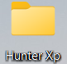  I made a folder called Hunter XP on my Windows desktop and added two subfolders named Casefile and Evidence.  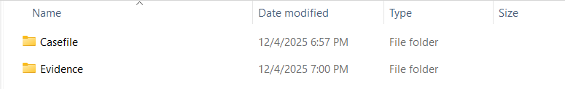  The Casefile folder served as the database for Autopsy, which I loaded during the analysis. The Evidence folder contained the Hunter XP disk image (EO1 format).  Next, I used Autopsy to load and analyse the disk image.  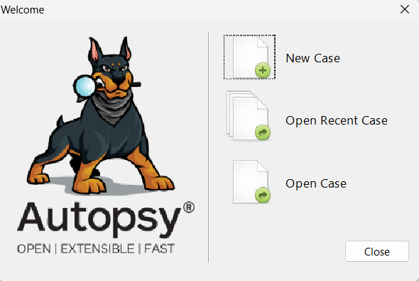  This was the interface that appeared when I opened Autopsy for the first time. Since I was starting a new investigation, I clicked New Case.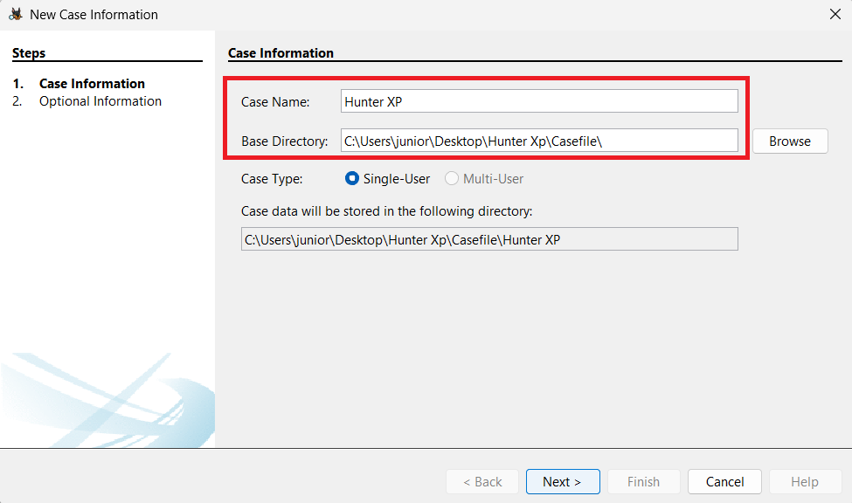  After selecting New Case, I entered the required information, including the case name and the base directory.  In the Optional Information section, I entered the case number, name, phone, and email, and then clicked Finish.  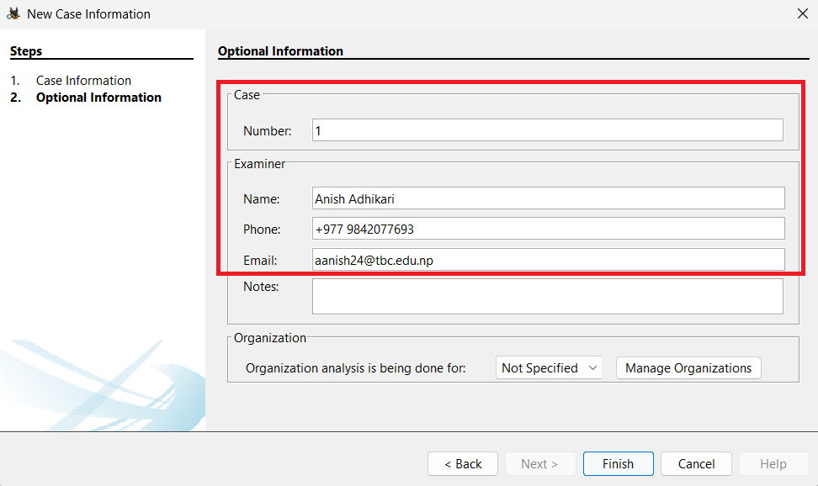  After this, the Add Data Source window popped up, where I entered the required information  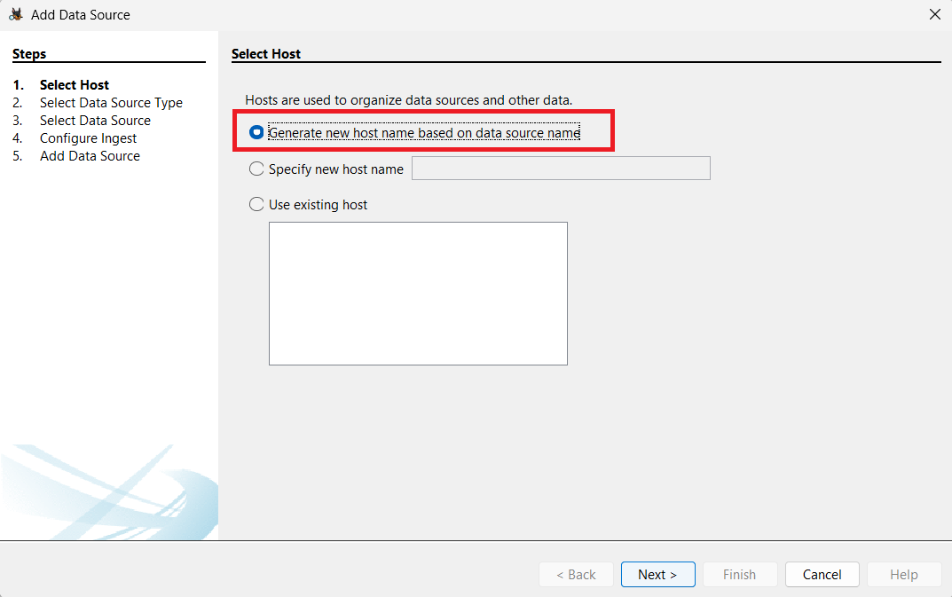  We will select the 1st option as itself and click on Next.  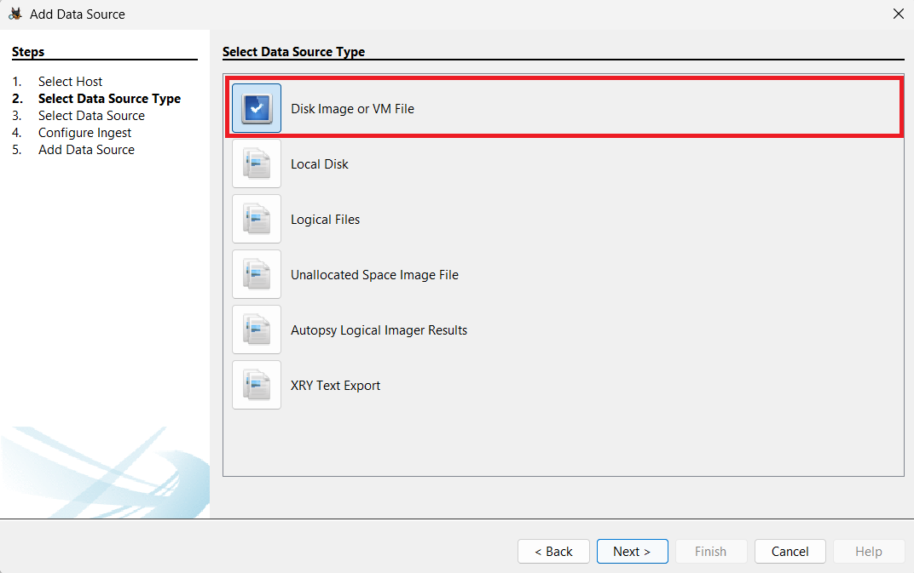  Here, we selected Disk Image or VM File because we were going to analyse a disk image.  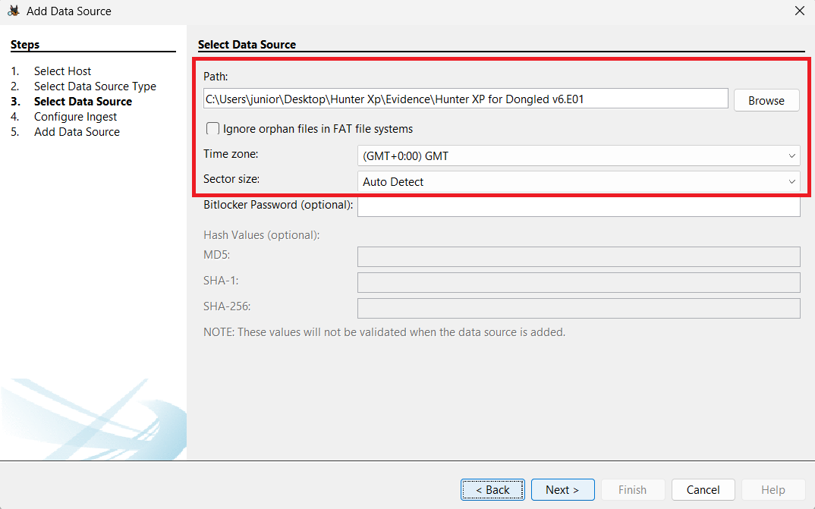  We then selected the disk image and specified its location, which was inside the Evidence folder, as mentioned earlier. Additionally, we set the time zone to (GMT +0:00) GMT.  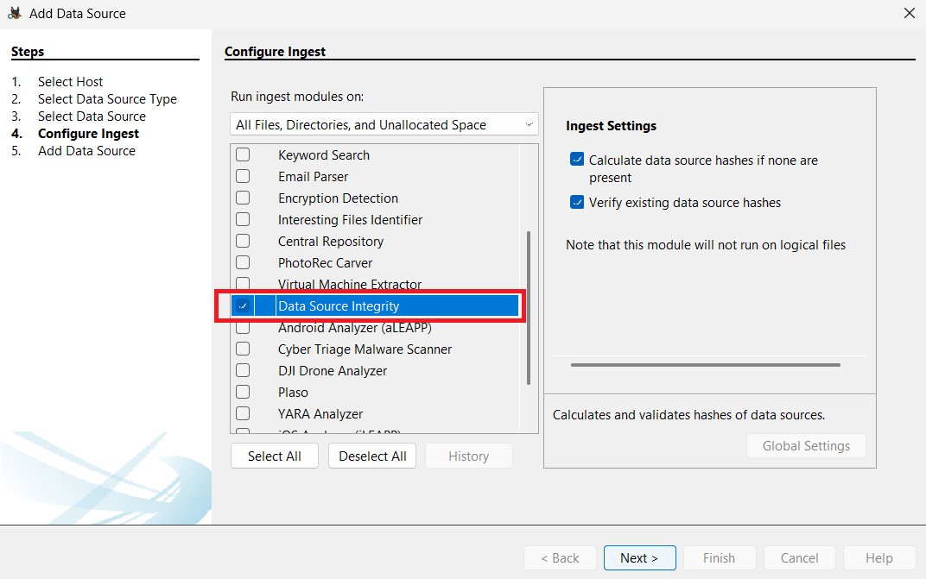  We selected only the Ingest Data Source Integrity module at first because the task was to load the case and verify the image. The other ingest modules were enabled later as needed.  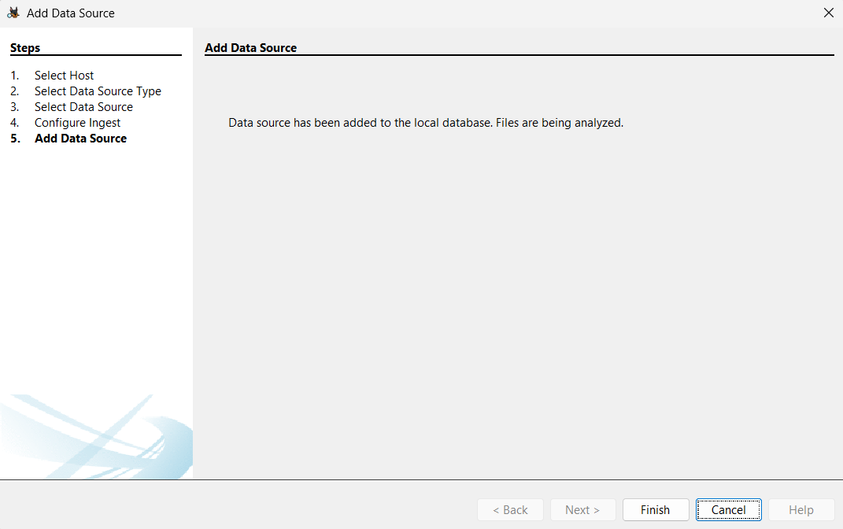  Here it shows that the data has been added to the local database. We proceed further by clicking ‘Finish’.  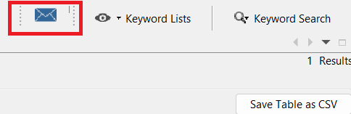  We clicked on the message type icon that appeared in the top right corner of the page.  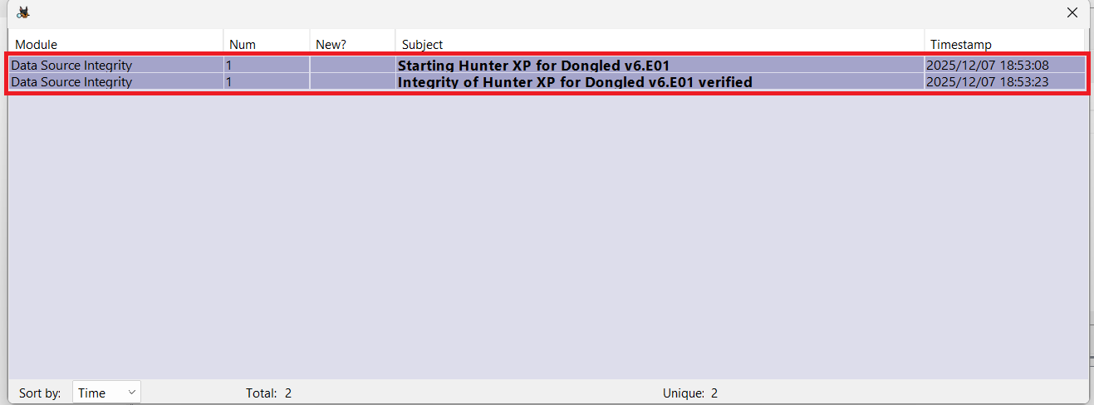  Here we could see that the data source integrity of the image file was verified.  Next, we clicked on the verified item and checked the hash value of the image.  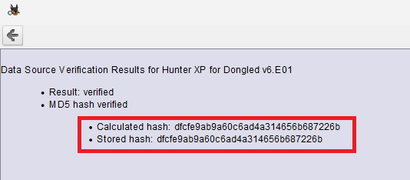  Finally, the computed hash values were:  Calculate hash: dfcfe9ab9a60c6ad4a314656b687226b  Stored hash: dfcfe9ab9a60c6ad4a314656b687226b
Load Case into second forensic tool for dual verification of at least 2 key artefacts, evidence items |  |  |  | For dual verification I will be using
Time Zone Adjusted?  Report Time Zone used for Analysis. |  |  |  | 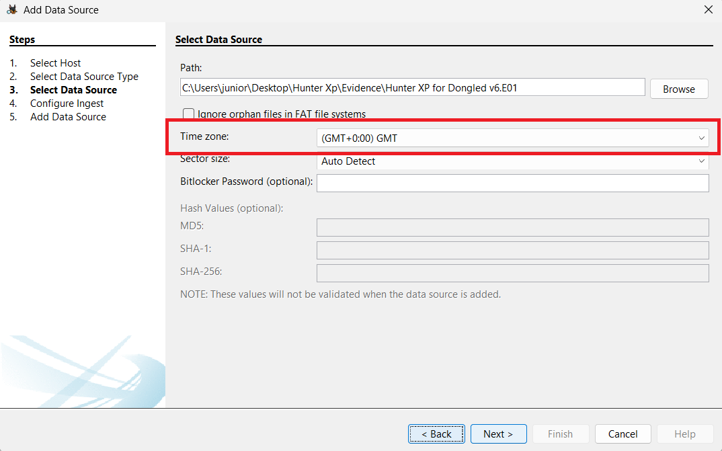  At the very beginning, the time zone was selected to (GMT +0:00) GMT.  We can also configure the time zone by clicking Tools > Options > View.  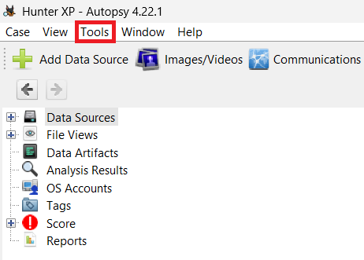  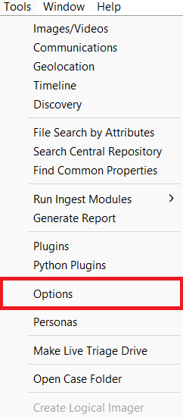  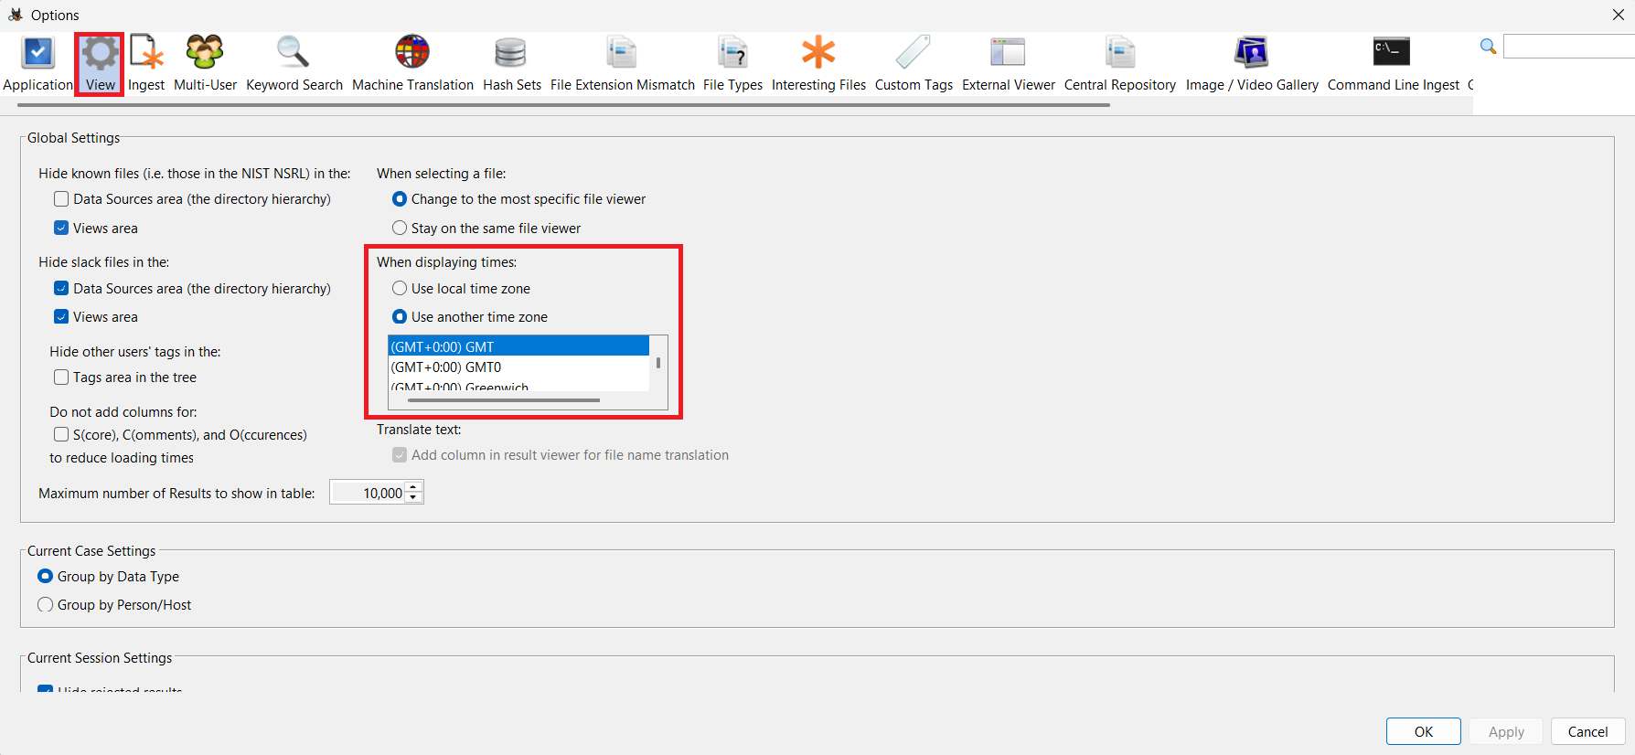  In the picture above, we saw that we could set the time zone by clicking "Use another time zone" and then clicking "Apply."
Recover lost folders  (NTFS, FAT16&32). |  |  |  | To recover the lost folder, I first installed the PhotoRec Carver module by navigating to Tools > Run Ingest Modules > Hunter XP for Dongled v6.E01.  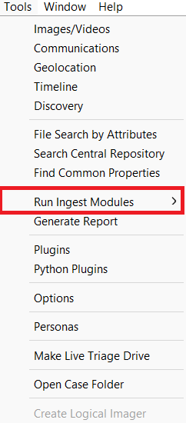  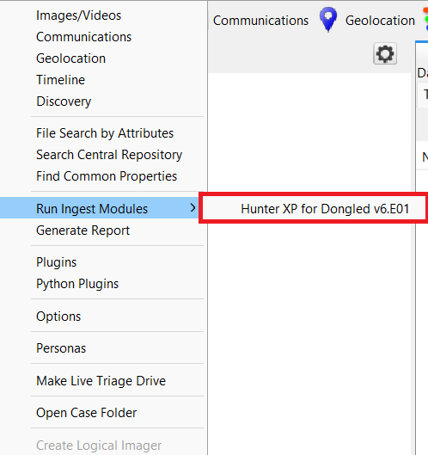  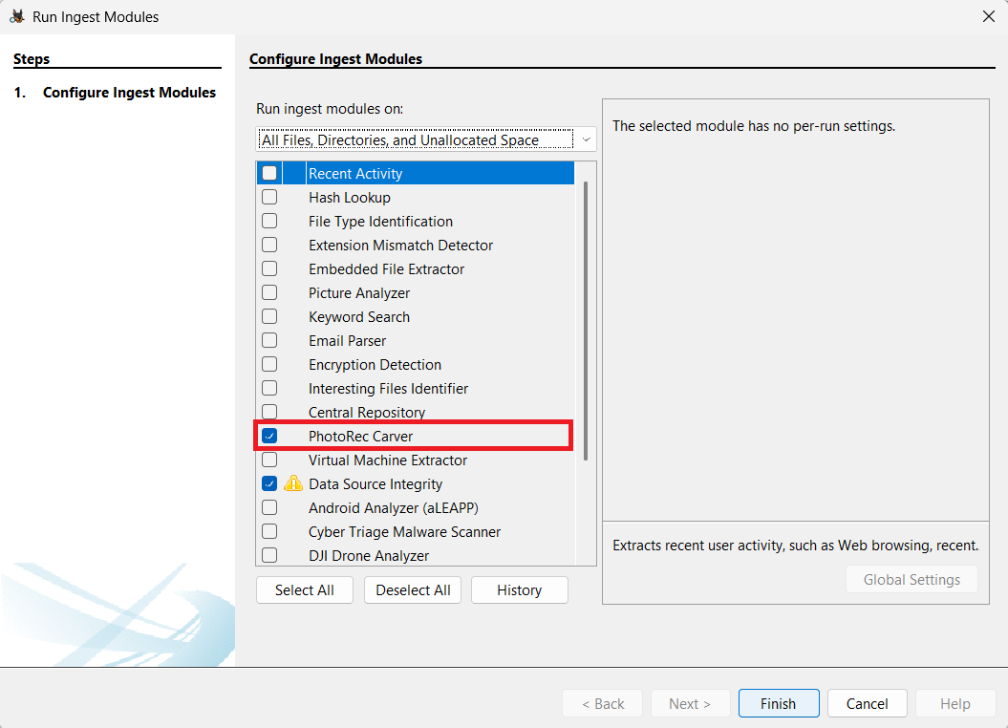  We clicked on "Finish" after selecting the PhotoRec Carver module.  After clicking "Finish," it took about 20 to 30 seconds to load the image from the PhotoRec Carver module.  We navigated to File view > Deleted Files > All (2137).  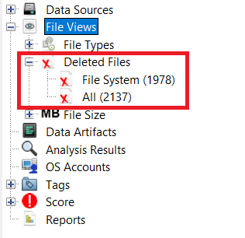  We saw that some files only had their metadata extracted, while others were fully recovered.  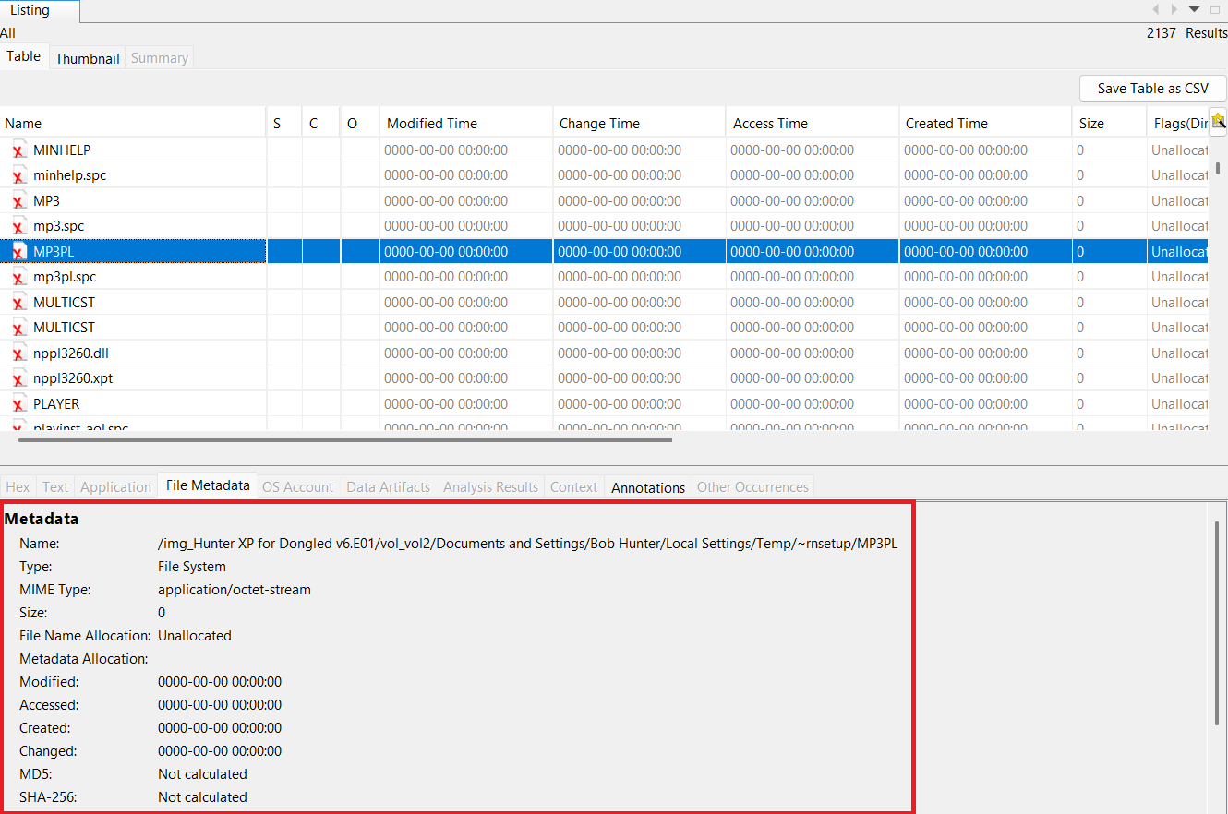  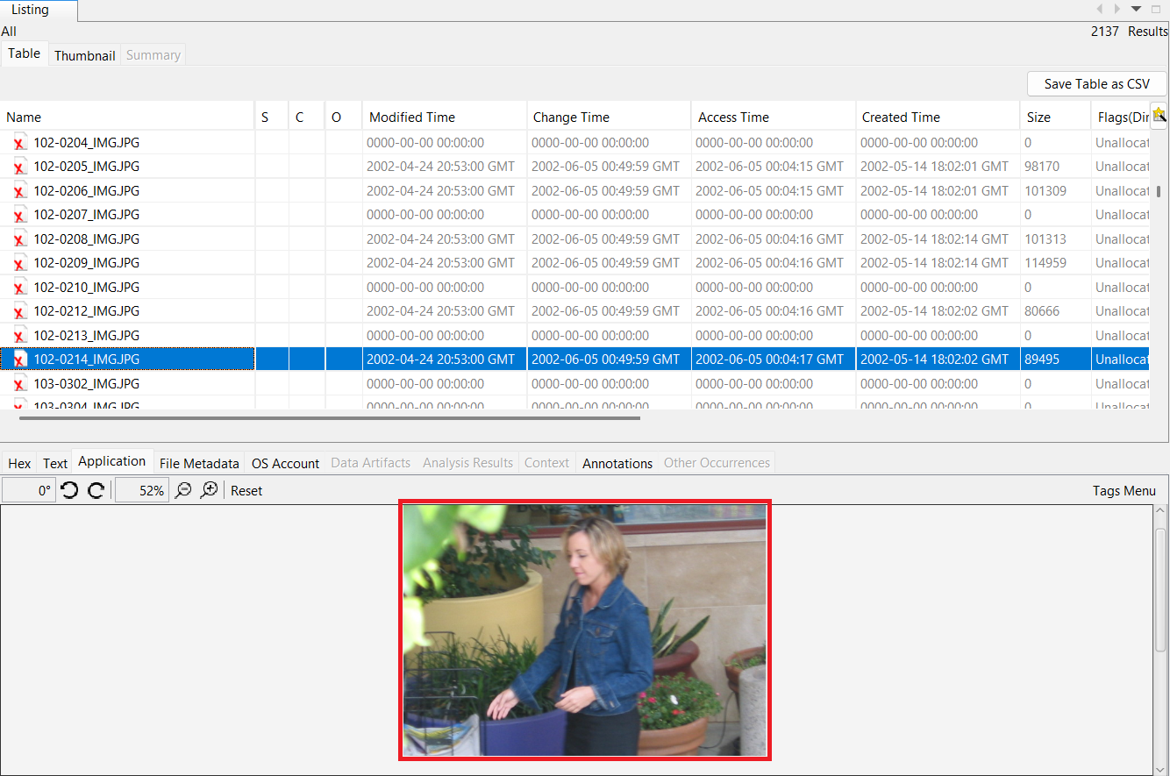
Mount archives;  zip, thumbs.db, etc. |  |  |  | The archive folder was in File Views > File Types > By Extension > Archives.  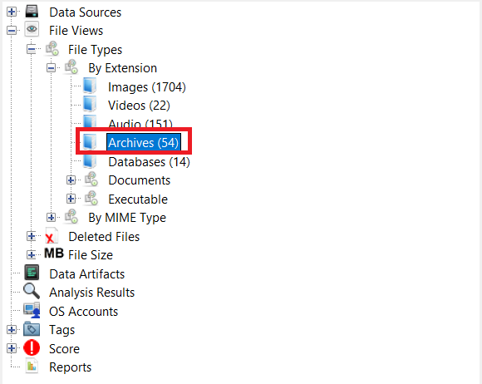
File signature analysis (any interesting file mismatch?);  Compute hash values (enable entropy computation) |  |  |  | To complete this, I first installed the ingest modules: Hash Lookup, File Type Identification, Extension Mismatch Detector and Encryption Detection.  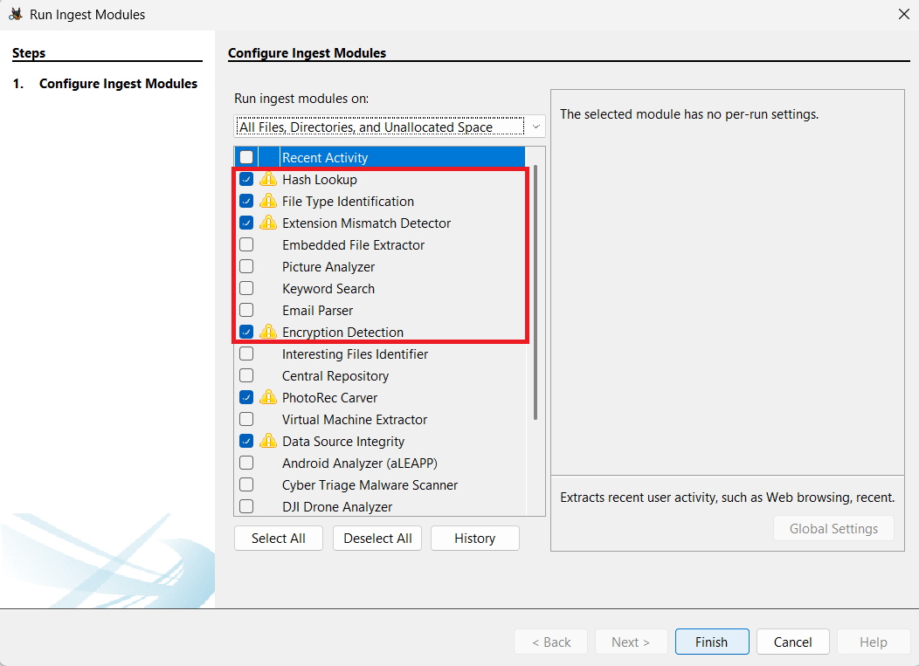  Under Analysis Result, we saw that 232 files with extension mismatch were detected.  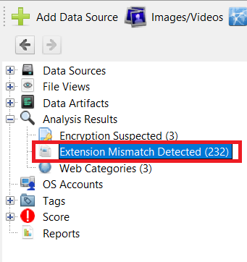  At this point, we noticed that the wbkC1.tmp file, although saved as a .tmp extension, was an image file.  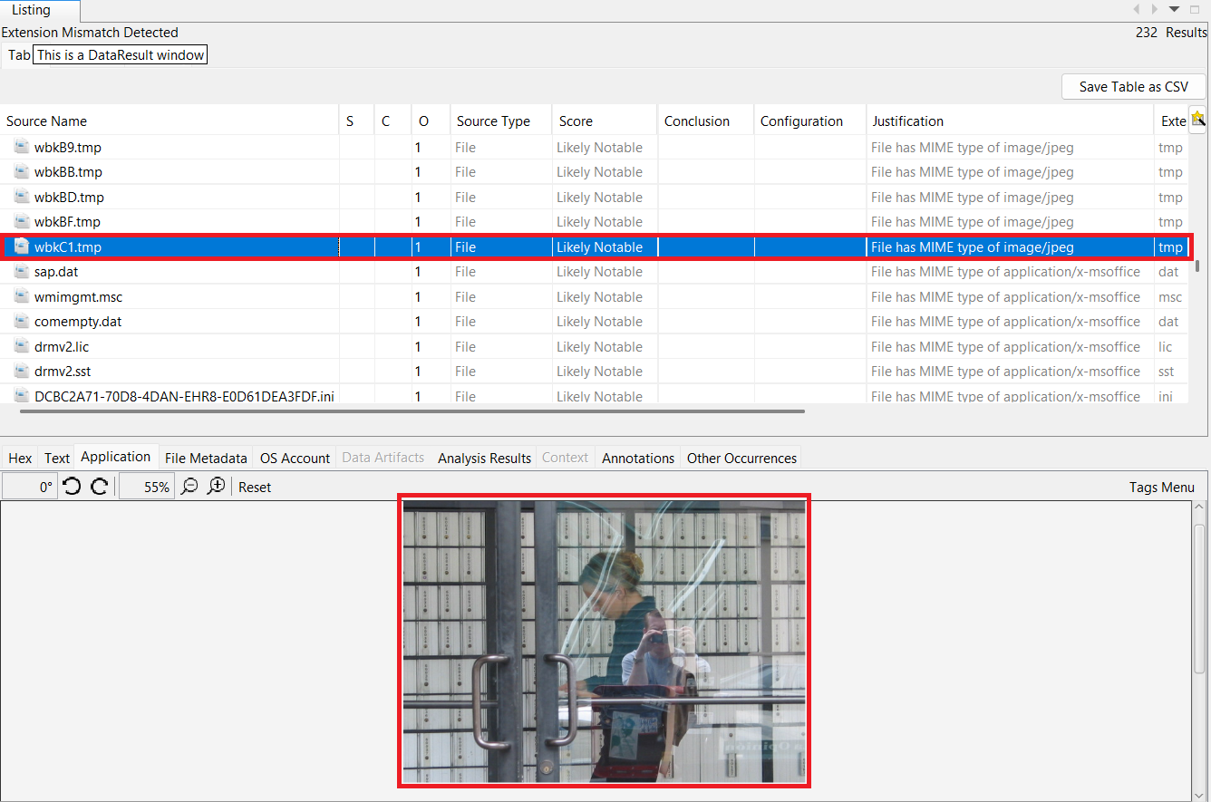  For Entropy:  Under the Encryption Suspected items, there was a file named oembios.bin that showed a high entropy value of 7.999988.  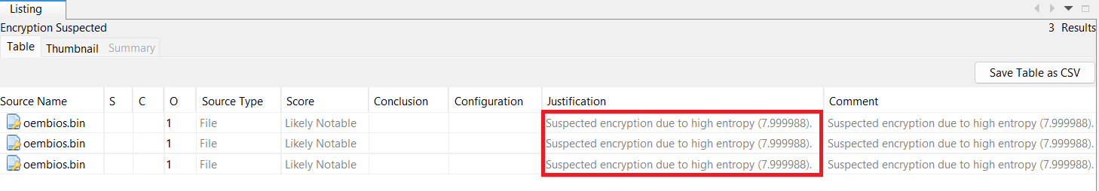
Internet History, favourites, etc.  Other browsers? |  |  |  | First, I installed two modules: Recent Activity and Plaso.  Under Data Artifacts, we were able to see the web history.  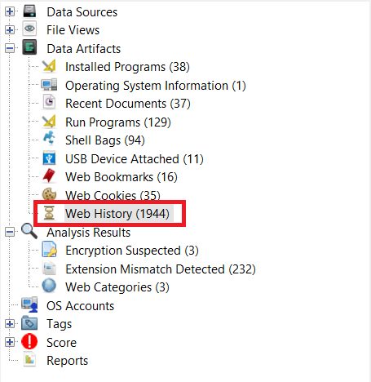  We could see the many websites that the user, Bob Hunter, had visited.  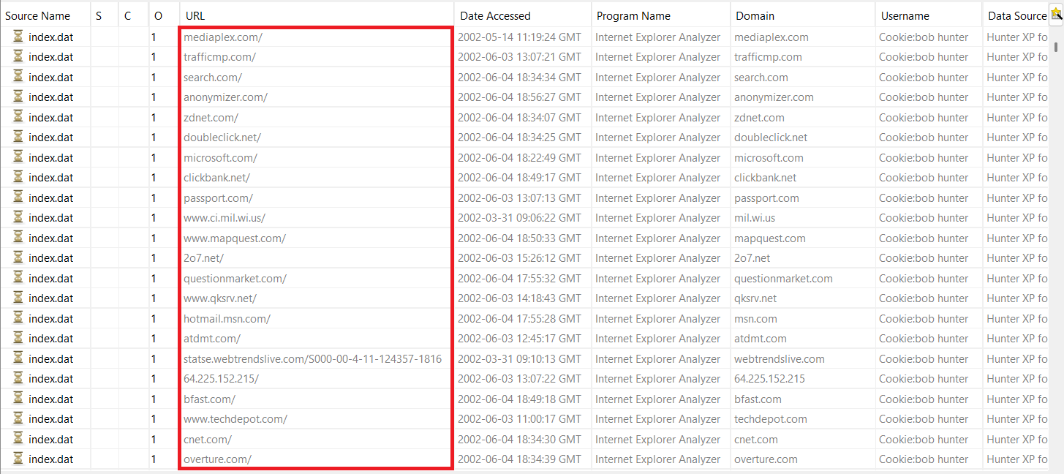  To locate the favourites, we went to the Web Bookmarks section and found that the user had bookmarked 16 websites, which were likely his favourites.  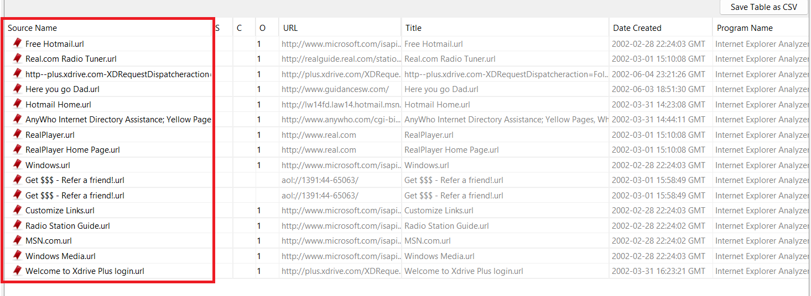  The browser used by the user appeared to be Internet Explorer. I checked the Installed Programs section and found entries such as IE40, IE5BAKEX, IE4Data, and IEData, all of which are components related to Internet Explorer.  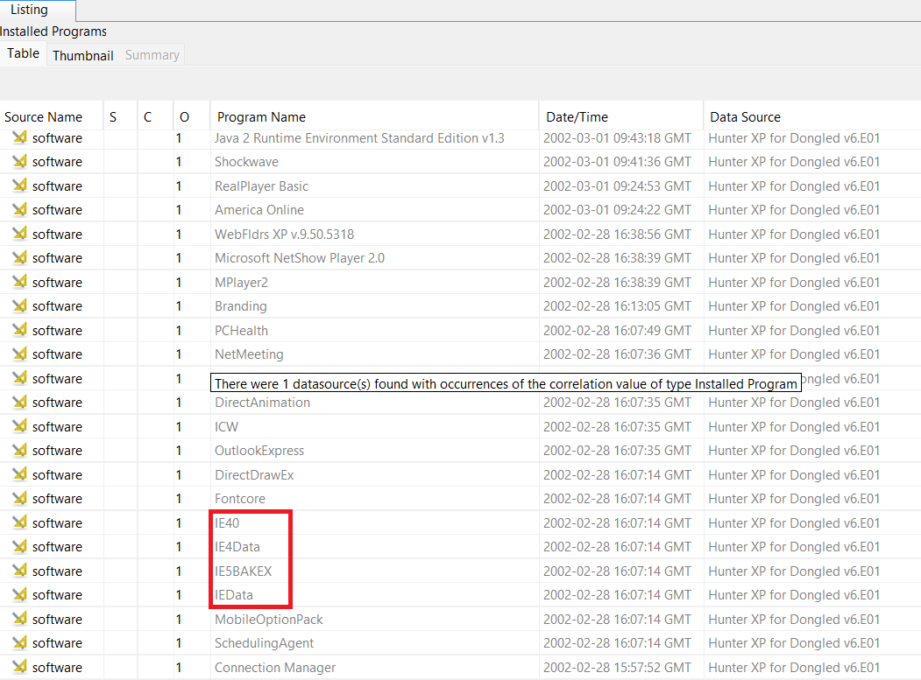
Emails, local and web-based. |  |  |  | To complete this, I first installed two modules: Keyword Search and Email Parser.  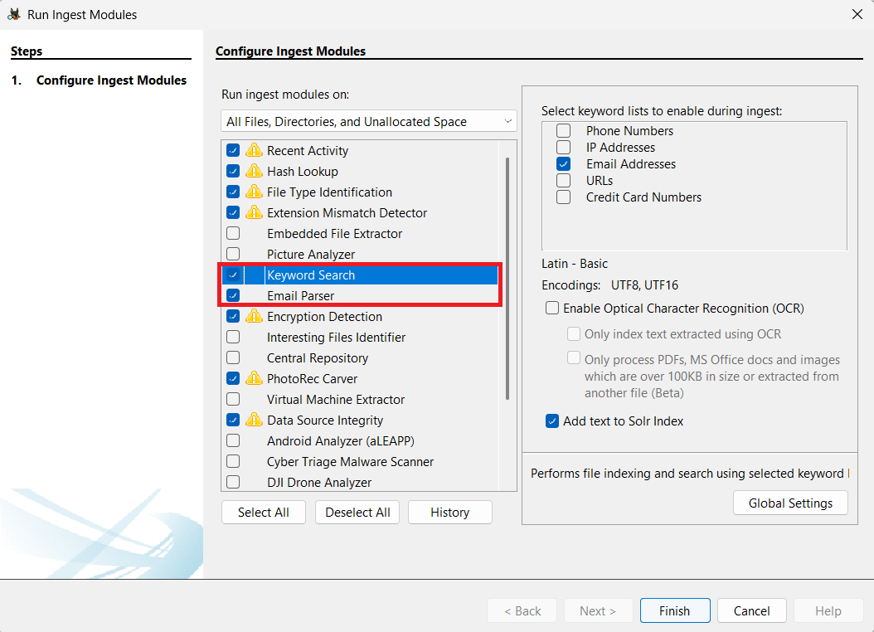
Retrieve operating system information, accounts information, software, time zone information etc.).
Timeline analysis-
Note date of last activity on the computer. System profiling.
Registry analysis and
Registry protected area
Link files and Recycle Bin
Instant Messaging clients
Clean-up/Wiping utilities. Check log files. Anything used?
External drives; Network connections
Perform data carving
Run relevant keyword searches;
Did you index the evidence file?
Recover Log-on passwords –
use SAMInside/Ophcrack/Encase
Examine different file types:
Export doc/office and exe files; look at Metadata if required
Encryption, Steganalysis (any indications? Entropy or Autopsy can be used)
Print artefacts
CD/DVD burning apps; check log files
Validate evidence integrity at the end of the examination

Additional Notes/Artefacts Examined:

Colour-coding Legend | Tasks
 | Fundamental
 | Basic
 | Elementary
 | Secondary
 | Advanced
 | Exceptional

